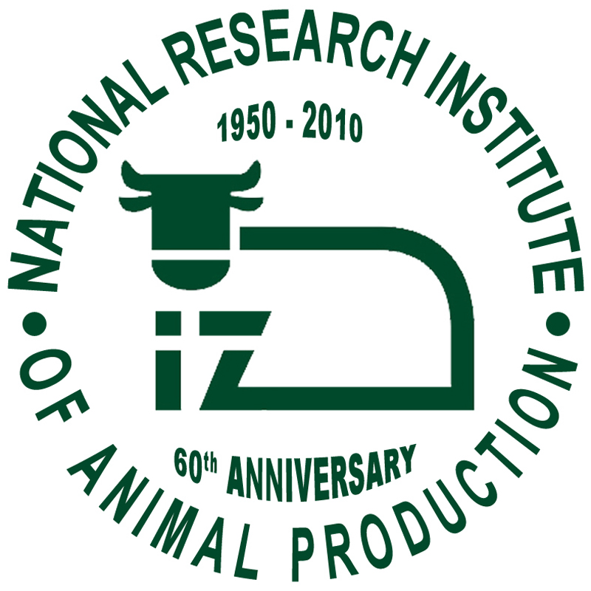
National Research Institute of Animal Production, Balice, Poland

Abstract Submission Form
19th International Colloquium on Animal Cytogenetics and Gene Mapping
JUNE 6th – 9th, 2010, Krakow – Poland

I. Topics (please choose from list below and print here):
.
- Clinical cytogenetics
- Molecular cytogenetics
- Comparative genomics and karyotype evolution
- Cytogenetics of germ cells and embryos
- Genes mapping and expression
- Mutagenesis
- Epigenetic mechanism
- New technology of molecular cytogenetics
- Cytogenetics of fish and other cold blooded vertebrates

II. Presenting Form (please specify the preferable way of abstract presentation: Oral Communication or Poster): .

III. Title:

IV. Authors (please insert the list of authors in the order as indicated below and underline the name of presenting author):

first name initial(s), last name, affiliations (full name of department, full name of institution, city and country).

1.
2. .
3. .
4.

V. Abstract (maximum 250 words):

